Project Design Phase-II
Technology Stack (Architecture & Stack)

Date | 8 January 2026
Team ID | LTVIP2026TMIDS24884
Project Name | Heart Disease Analysis
Maximum Marks | 4 Marks

Technical Architecture:
Technical Architecture defines the structured design of a system, showing how different components like user interface, application logic, database, and visualization tools interact to deliver the final solution.
Example: Online Shopping System
Reference: https://help.tableau.com/
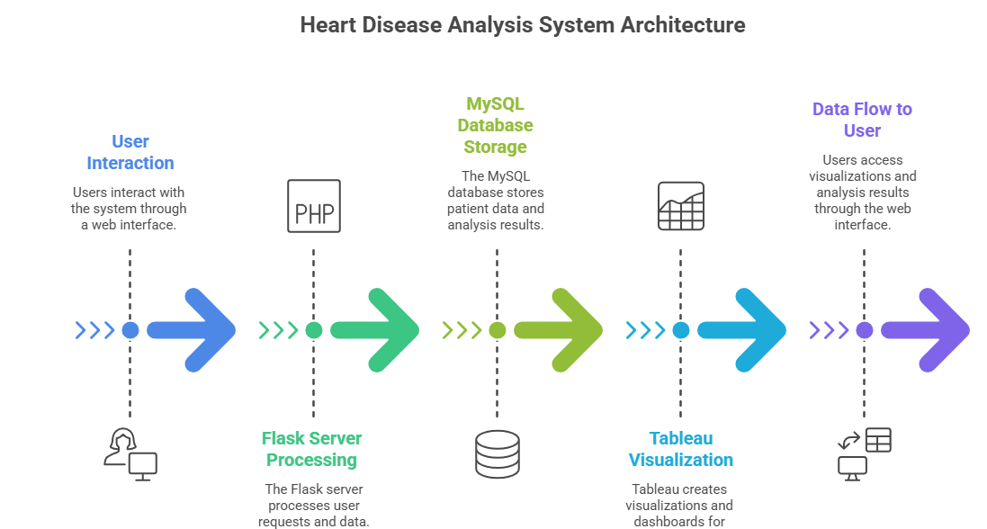

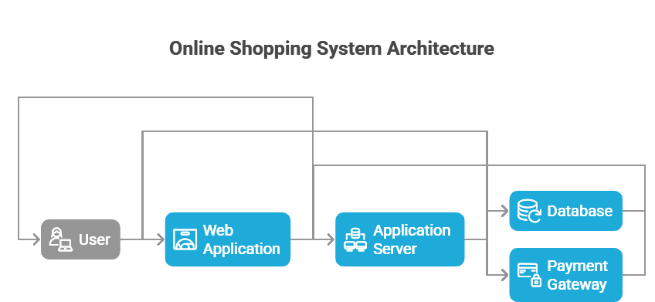

Table-1 : Components & Technologies:
S.No | Component | Description | Technology
 | User Interface |  | HTML, CSS, JavaScript
  Web-based dashboard where users register, login, and view heart disease analytics reports
 | Application Logic-1 | Backend logic for authentication, session management, data filtering, and report generation | Python with Flask Framework
 | Application Logic-2 | Data processing logic for cleaning, transforming, and preparing dataset for visualization | Python (Pandas, NumPy)
 | Application Logic-3 | Dashboard integration and analytics embedding | Tableau
 | Database |  | MySQL
  Stores structured heart disease dataset (Age, BMI,
  Cholesterol, Smoking, Diabetes, etc.)
 | Cloud Database | Optional cloud-hosted relational database for remote deployment | IBM DB2.
 | File Storage | Stores CSV dataset files and exported reports | Local File System / Cloud Storage
 | External API-1 | Email service API for user confirmation and OTP verification | SMTP API
 | External API-2 | Optional health dataset integration API (future enhancement) | Public Health Data API
 | Machine Learning Model | Predicts heart disease risk based on health parameters | Logistic Regression / Random Forest (Scikit-learn)
 | Infrastructure (Server / Cloud) | Application Deployment Environment | Local Server (Windows/Linux) / AWS EC2 / IBM Cloud

Table-2: Application Characteristics:
S.No | Characteristics | Description | Technology
 | Open-Source Frameworks | Backend and data processing frameworks used | Flask, Pandas, NumPy, Scikit-learn
 | Security Implementations | Password hashing, secure login, input validation, protection against SQL Injection | SHA-256 Hashing, HTTPS, OWASP Guidelines
 | Scalable Architecture |  | Flask + MySQL + Tableau
  3-Tier Architecture separating UI, Logic, and Database layers
 | Availability |  | AWS EC2 / IBM Cloud
  System can be hosted on cloud with continuous uptime
 | Performance | Optimized SQL queries, indexed database, caching static files | MySQL Indexing, Flask Caching

References:
https://c4model.com/
https://www.ibm.com/cloud/architecture
https://aws.amazon.com/architecture/
https://flask.palletsprojects.com/
https://dev.mysql.com/doc/

